A1121 Afr-Egy-Ushabti-New Kingdom-19th Dynasty-1293-1189 BCE

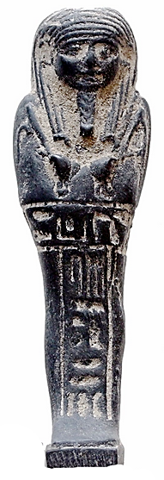

Fig. 1.

**Case No.:**

**Formal Label:**

**Display Description: Mummiform. Tripartite wig with incised striations and worn low on the forehead with small side tabs indicated just in front of the ears. Plaited divine beard suggests a royal attendant. The arms are crossed on the chest, clenched hands are protruding from a shroud with the right holding a broad-bladed hope and the left a narrow bladed hoe in relief. One basket is indicated as being slung over the left shoulder with its braided cord being held in the left hand. There is an incised T shaped inscription naming the owner.**

This Ushabti was made for an attendant of the court of Menmaatre **Seti I**, reigned ca 1290-1279 BCE, the son of Ramesses I and Sitre, and the father of Ramesses II.

**Accession Number: 1121**

**LC Classification:** DT62

**Date or Time Horizon:** New Kingdom, 19th dynasty-1293-1189 BCE

**Geographical Area:**

**Map, GPS Coordinates:** 24.933333, 32.833333; 24° 56' 00" N, 32° 50' 00" E.

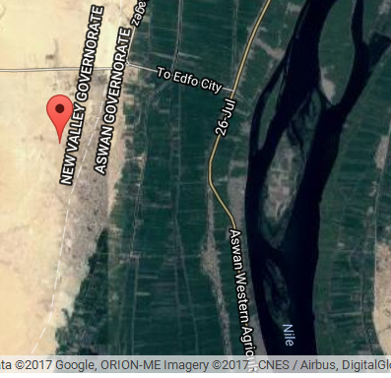

**Cultural Affiliation:** New Kingdom, 19th dynasty-1293-1189 BCE

**Medium**: black serpentine.

**Dimensions:** H 68 mm; W 19 mm; T 14 mm   
**Weight:** 12.42 gm

**Provenance:** Stavros Nicolaides Alexandrou Papadiamandi, 7020 CYPRUS, Larnaca

**Condition: original**

**Discussion:** Enormous social upheavals had been caused by Akhenaten's religious reform so that Seti I re-established stability and reasserted Egypt's sovereignty over Canaan and Syria, which had been under threat from the Hittites, which he confronted but failed to eliminate as a threat but` he reconquered most of the disputed territories with military successes. His funerary temple was constructed in Qurna on the west bank of the Nile at Thebes and his capital was at Memphis.

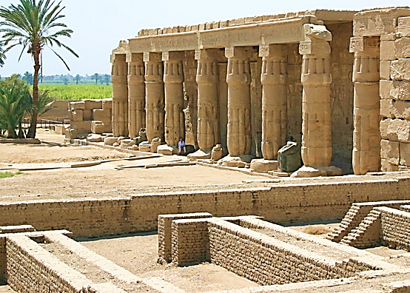

Fig. 2. Mortuary Temple of Seti I at Qurna, on the west bank of the Nile at Thebes. After https://upload.wikimedia.org/wikipedia/commons/6/6a/Seti_I_Temple_at_Qurna.jpg

**References:**

Aubert, J.-F. et L. Aubert. 1974. *Statuettes Egyptiennes: Chaouabtis, Ouchebtis.* Paris, 1974.

Janes, Glenn. 2002. *Shabtis. A Private View, Ancient Egyptian Funerary Statuettes in European Private Collections.* Paris: Cybèle.

Newberry, Percy E. 1930-1957. *Funerary Statuettes and Model Sarcophagi.*  Le Caire: Impr. de l'Institut français d'archéologie orientale.

Schneider, Hans D. 1977. *Shabtis - An Introduction to the History of Ancient Egyptian Funerary Statuettes. With a Catalogue of the Collection of Shabtis in the National Museum of Leiden*. (3 volumes, Leiden: Rijksmuseum van Oudheden Te Leiden.

Schlögl, Hermann and Andreas Brodbeck. 1990. *Ägyptische Totenfiguren aus öffentlichen und privaten Sammlungen der Schweiz.* Orbis Biblicus et Orientalis, Series Archeologica, 7. Göttingen, Vandenhoeck & Ruprecht; Freiburg Schweiz, Universitätsverlag.